Wilson Catcher’s mitt
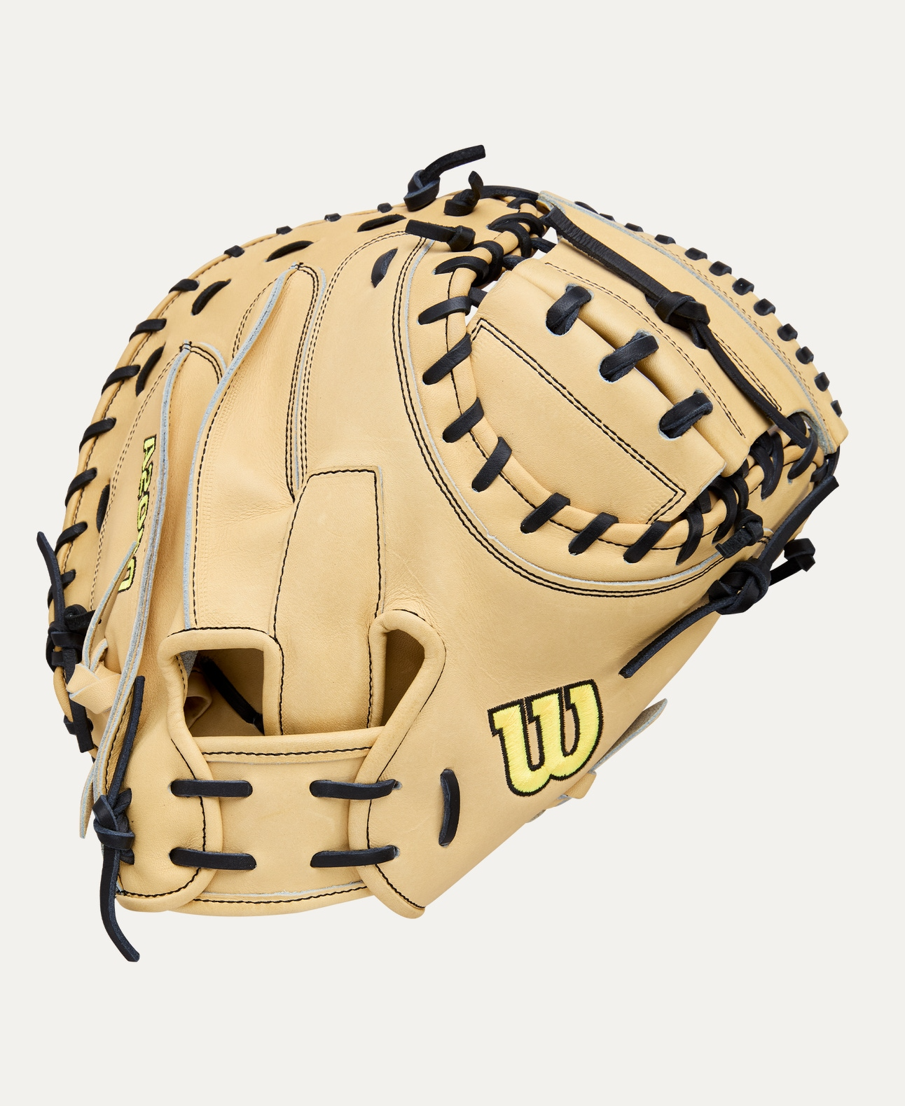
Price: Approximately RS 8,000

Introduction
The Wilson Catcher’s Mitt is designed to provide superior control, protection, and durability for catchers. Built to handle high-speed pitches, it ensures confidence and comfort behind the plate during games and practice.

Product Overview
This Wilson Catcher’s Mitt features a deep pocket and reinforced padding to securely catch and control fast throws. Its ergonomic shape helps reduce impact while allowing quick ball transfers.

About the Brand
Wilson is a globally trusted sports brand known for producing professional-grade baseball gloves and equipment. Wilson catcher’s mitts are widely used by amateur and professional players for their quality and performance.

Key Features
- Deep pocket for secure ball catching
- Extra padding for impact protection
- Strong lacing for long-lasting shape
- Comfortable fit with adjustable closure
- Game-ready or break-in friendly design

Design & Build Quality
The mitt features a classic catcher’s design with reinforced palm and thumb areas. Precision stitching and strong lacing ensure excellent shape retention and durability over time.

Storage & Capacity
Compact and easy to store in a baseball gear bag without losing form when properly maintained.

Material & Durability
Made from premium leather or high-quality synthetic material (model dependent), the Wilson Catcher’s Mitt is built to withstand repeated impact and intensive use.

Ideal For
- Baseball and softball catchers
- Youth, amateur, and professional players
- Training sessions and competitive games
- School and academy teams

Care Instructions
- Clean with a soft, dry cloth after use
- Use glove conditioner periodically
- Store with a ball in the pocket to maintain shape
- Avoid excessive moisture and heat

Product Specifications
- Brand: Wilson
- Product Type: Catcher’s Mitt
- Material: Leather / Synthetic
- Pocket Type: Deep pocket
- Fit Type: Adjustable wrist closure
- Usage: Training & Match Play

Product Summary
The Wilson Catcher’s Mitt delivers reliable protection, excellent control, and long-lasting performance. Designed with trusted Wilson craftsmanship, it is an essential glove for catchers seeking comfort and confidence behind the plate.
Thank you

